**Mosfet Temperature Test**

In this test, we have tried to find the correct value of the mosfets junction and case temperature and comparing it with the analytical results, for that purpose, 24 volt input is given (to create worst case condition) and in lt spice there is a heat sink model which we can create the one that we choose in simulation environment. whole circuit is like below.

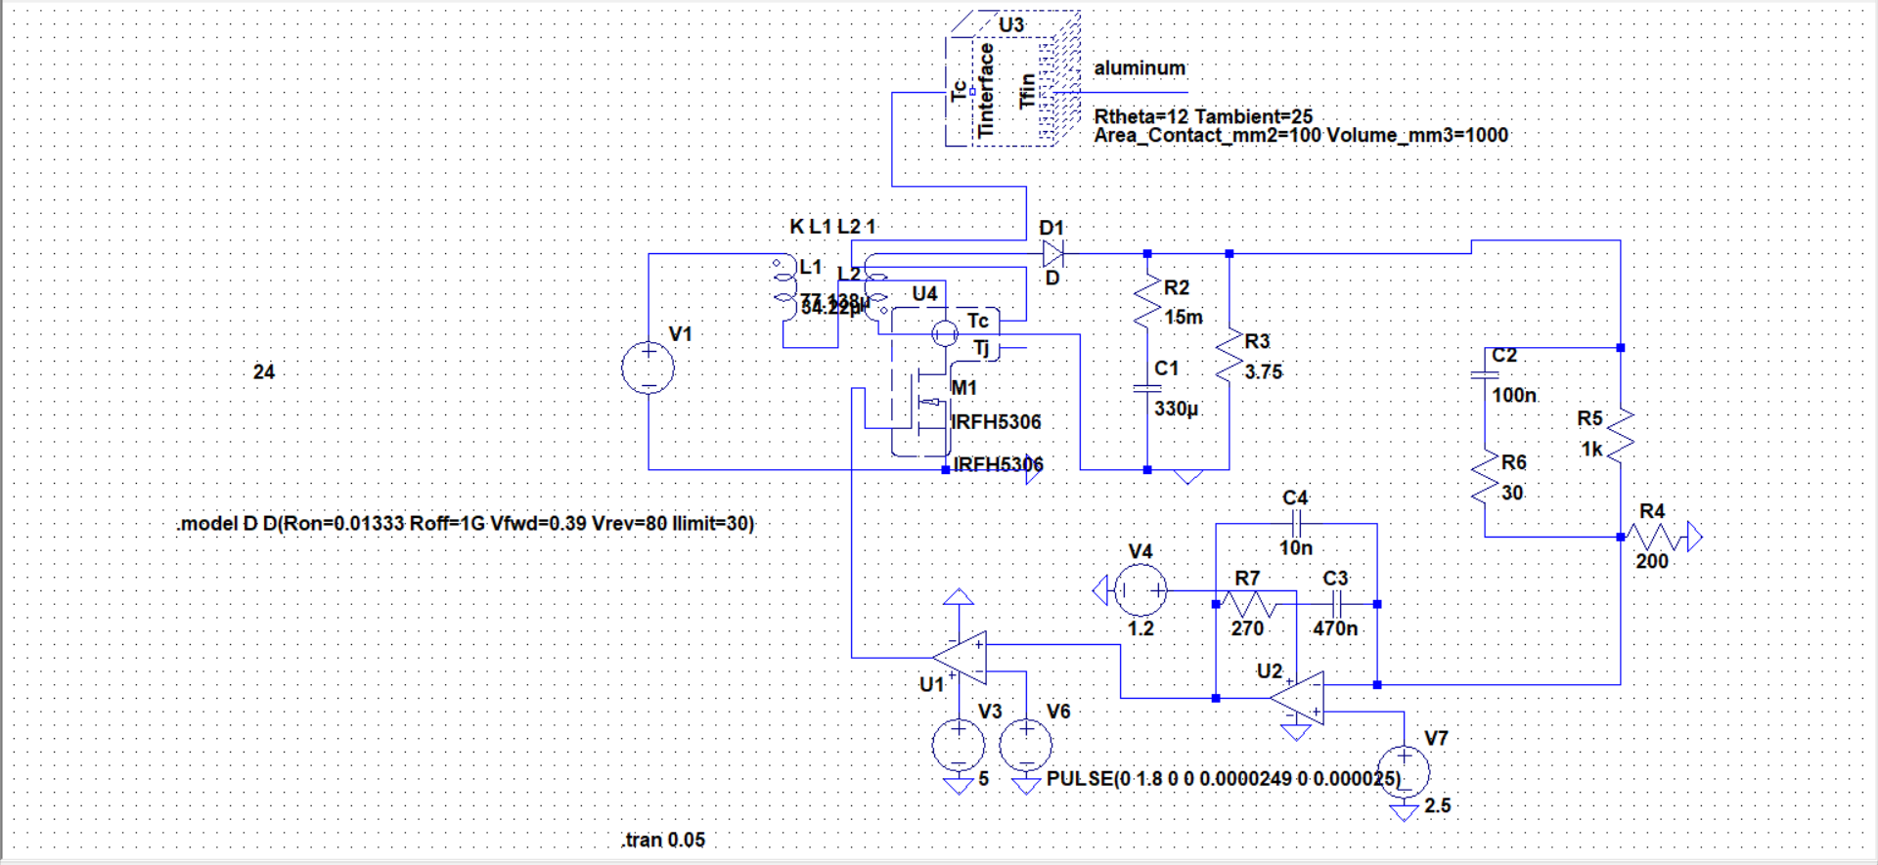

FigureXX: thermal design simulation.

For that purpose, The junction to case and case junction resistances of the mosfer will be found which is similar to our mosfet, also, the found heatsink temperature resistance is also given.

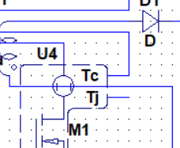

Figure Tc junction

From the above node(Tj) , we have measured the combined temperature of the junction

and results are as below.

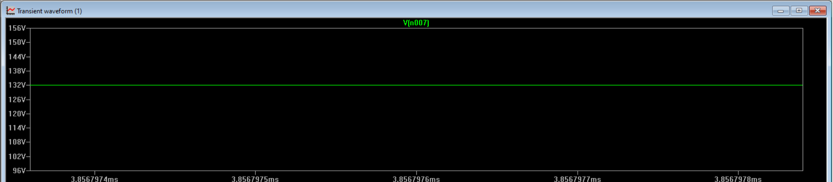

FigureXX: junction temperature of the mosfer.